Problem and Solution
In our community, the primary issue we face is the deficiency in skills among residents, coupled with the absence of connections between individuals seeking particular services and those possessing the requisite skills. For instance, consider a scenario where your neighbor requires assistance in professionally disassembling a cupboard or wall unit in exchange for monetary compensation, but struggles to find someone locally with the necessary expertise due to the lack of a centralized platform or network facilitating such connections.
Description of Solution
This is where we come in, building upon the identified problem, our proposed solution is the introduction of our app, "Community Connect." This platform will serve as a centralized hub where community members can come together to exchange their valuable skills for monetary compensation. Through "Community Connect," individuals in need of specific services, such as professional furniture disassembly, can easily connect with skilled individuals within the community willing to provide those services in exchange for payment. By facilitating these connections, our app aims to bridge the gap between those seeking skills and those offering them, thereby addressing the core issue of skill deficiency and lack of connections within our community.

Entity Relationship Diagram
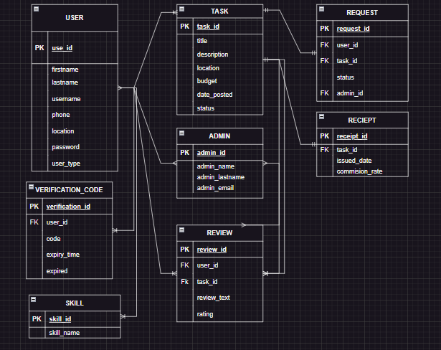

Wireframes
1. Home Page/ Landing Page

2. Sign In

3. Sign Up

Forgot password:

Browse Connectors 1 / 2:

Browse Connectors 2/2:

Connectors Page:

Edit Profile Page

Painting
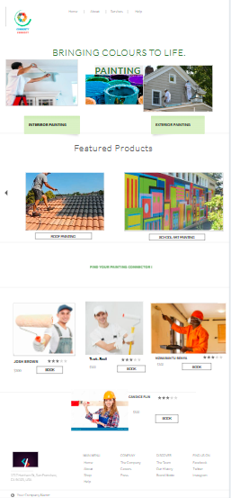

MOVING
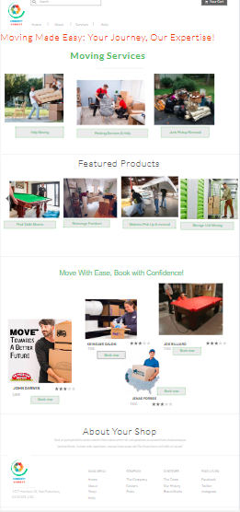

MOUNTING.
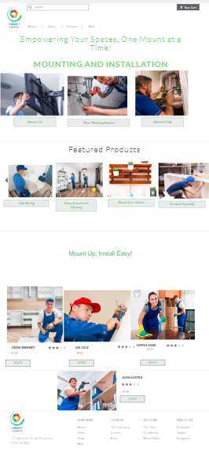m

Landscaping
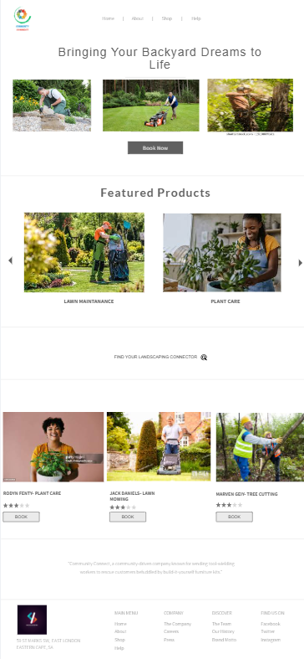

Housework

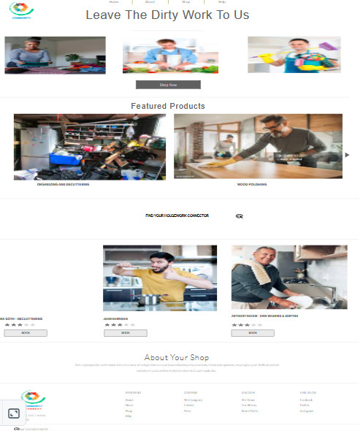

Shopping
